(HONORS) GEOMETRY NAME: _____________________
Unit 9 Lesson 3 Homework – Circumference and Arc Length BLK: _____ DATE: ___________

1. Find the circumference of the circle. Leave answer in terms of pi.

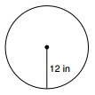

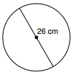
2. Find the circumference of the circle. Leave answer in terms of pi.

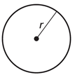
3. Find the radius of a circle with a circumference of $34π$ inches.

4. Find the perimeter.

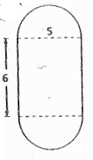

5. Find the length of the indicated arc.

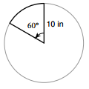

6. Find the length of the indicated arc.
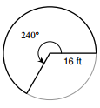

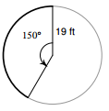
7. Find the length of the indicated arc.

8. Find the length of the indicated arc.
